|  |  |  |  |
| --- | --- | --- | --- |
| **TITLE:** |  | | |
| **sop #:** |  | **revision #:** |  |
| **EFFECTIVE DATE:** |  | | |
| **OWNER:** |  | | |

## REVIEWERS

|  |  |  |  |
| --- | --- | --- | --- |
| Name | tITLE | sIGNATURE | dATE |
|  |  |  |  |

## APPROVER

|  |  |  |  |
| --- | --- | --- | --- |
| Name | tITLE | sIGNATURE | dATE |
|  |  |  |  |

# 1.0 purpose

The purpose of this document is to provide an overview of the functions of the Admin Accounts Payable department at Radiant Global Logistics (Canada) Inc.

# 2.0 SCOPE

These procedures describe the tasks performed by Account Payable Specialist Non-Trade payments to vendors and suppliers to Radiant Global Logistics (Canada) Inc.

# 3.0 equipment

N/A

# 4.0 definitions

|  |  |
| --- | --- |
| **Definition** | **Explanation** |
| **AP** | Accounts Payable |
| **APS** | Accounts Payable Specialist |
| **Non-Trade Payables** | Payment to vendors to Radiant Wheels Canada that provide services unrelated to the core business. |

# 5.0 Responsibility

| **Responsibility** | **Activity** |
| --- | --- |
| **A/P Team Leader or**  **Administration Manager** | * It is the responsibility of the Administration manager or Accounts Payable Team leader to ensure that Account Payable Specialists (APS) adhere to these procedures * It is the responsibility of the Administration manager or Accounts Payable Tea Leader to assist the (APSs) is the resolution of any payment issues |
| **Accounts Payable Specialist (APS)** | * It is the responsibility of the ARSs to ensure that these procedures are followed. * It is the responsibility of the ARS to resolve minor issue and bring larger issues to the attention of the AP Team Lead or Administration Manager. * The non-trade APS group receives an invoice generated by a vendor. |

# 6.1 procedure

6.1.1 The non-trade APS group receives an invoice generated by a vendor.

6.1.2 The non-trade APS sorts the invoices by company and will investigate any invoices that require clarification (what service is the invoice for?)

6.1.3 Invoices will be sent to approver for sign off and will remain on-hold until the approver has signed off.

6.1.4 The non-trade APS will enter the invoice into the Voucher Entry Screen of Epicor. Note: An electronic voucher will be generated with the invoice number on it.

6.1.5 Reference the voucher number, and due date on the invoice.

6.1.6 File invoice by due date in the payment drawer.

6.1.7 Post vouchers in Epicor twice per week (normally Tuesday (budget) & Friday (cheque run)). Run the aged payables report twice per week. 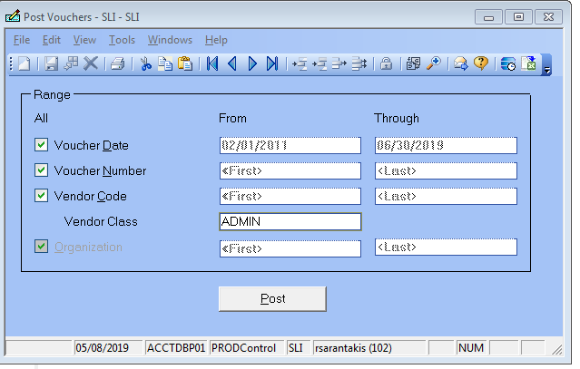

IF YOU WANT TO POST ONLY ONE SINGLE VOUCHER, CHECK THE VOUCHER NUMBER BOX AND YOU STILL HAVED

CHECK THE VENDOR CLASS BOX AS WELL. ALWAYS VENDOR CLASS ADMIN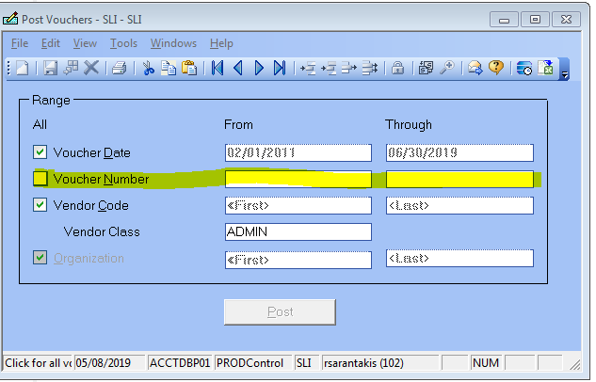

TYPE IN VOUCHER NUMBER IN THE FROM AND THROUGH BOX

6.1.8 If there are any error messages in Epicor, resolve the issue and re-enter the information

6.1.9 Once there are no error messages in Epicor, conduct an audit with another APS to double check the following information: 1. Vendor name is correct; 2. Invoice numbers match; 3. Invoice amount matches. Note: If there are any errors, investigate and resolve.

6.1.10 Once the report has been reviewed and is deemed accurate, generate payments in the payments section of Epicor.

6.1.11 Run an unposted payment register and this total amount should be equal to total ageing amount. **Note:** if amounts do not match, investigate and resolve as required.

6.1.12 Bring unposted report to the administration manager for review and approval. Obtain sign off on the report. **Note:** Sign-off will indicate that cheques can be printed and or EFT payments can be processed.

6.1.13 Go to the scanning area to the dedicated cheque printer and print the cheques

6.1.14 Scan cheques and signed unposted report into the Transflo imaging system

6.1.15 Run another unposted payment register which will now have the associated cheque numbers.

6.1.16 Post payments in Epicor and run a payment register

6.1.17 All reports and registers get converted to MS Excel and are kept in Public on Fido under the AP Invoices/Admin Cheque Run/

6.1.18 Conduct a DCH upload in Epicor. Send the DCH upload file to Bank of Montreal by secure FTP

6.1.19 All reports are submitted to the Administration Manager for sign off and then are scanned into the Transflo imaging system.

6.1.20 Once invoices have been paid and posted, the invoices are scanned into the Transflo Imaging system and hard copies of payment registers and invoices are bundled together and filed in designated AP box by date range.

## 6.2 Generating eft payments

1. Open Voucher form and start new voucher. Make sure that you selected EFTCAD as Payment Method. Save and post voucher.

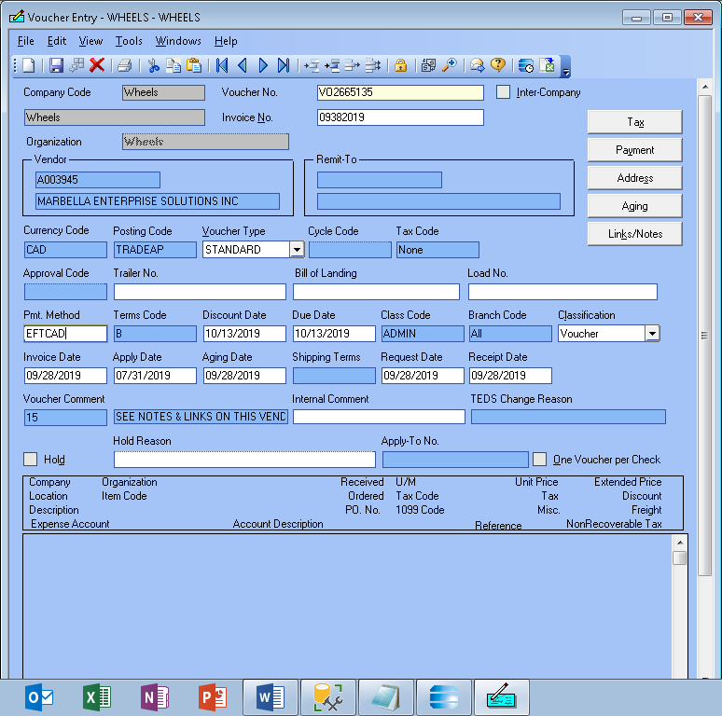

1. Be sure that the payment method in the vendor master is set to EFT and that the banking details have been entered by Admin Manager.

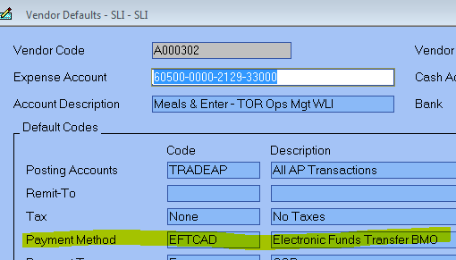

1. Open Generate Payments form and enter EFT payment. Make sure that you selected EFTCAD as Payment Method and CAD as Currency Code.

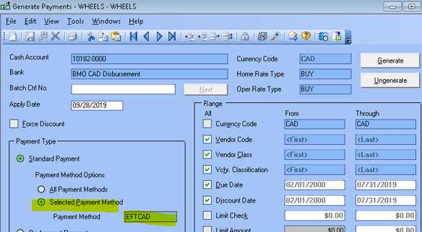

1. Expand Electronic Funds Transfer Folder

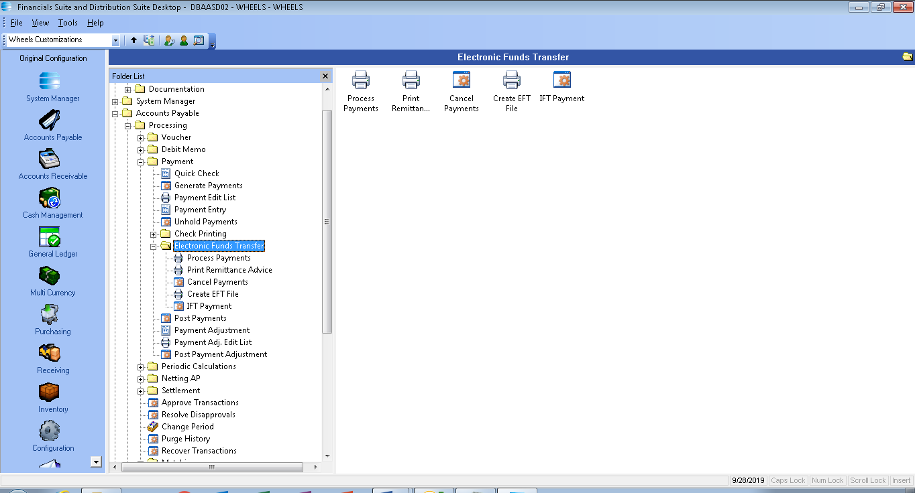

1. Open Process Payments form. Select New. On next screen select Parameters. On the next screen, select **BO CAD** as Cash Account cod and **EFTCAD** as Payment code .Click OK button . Continue to Process

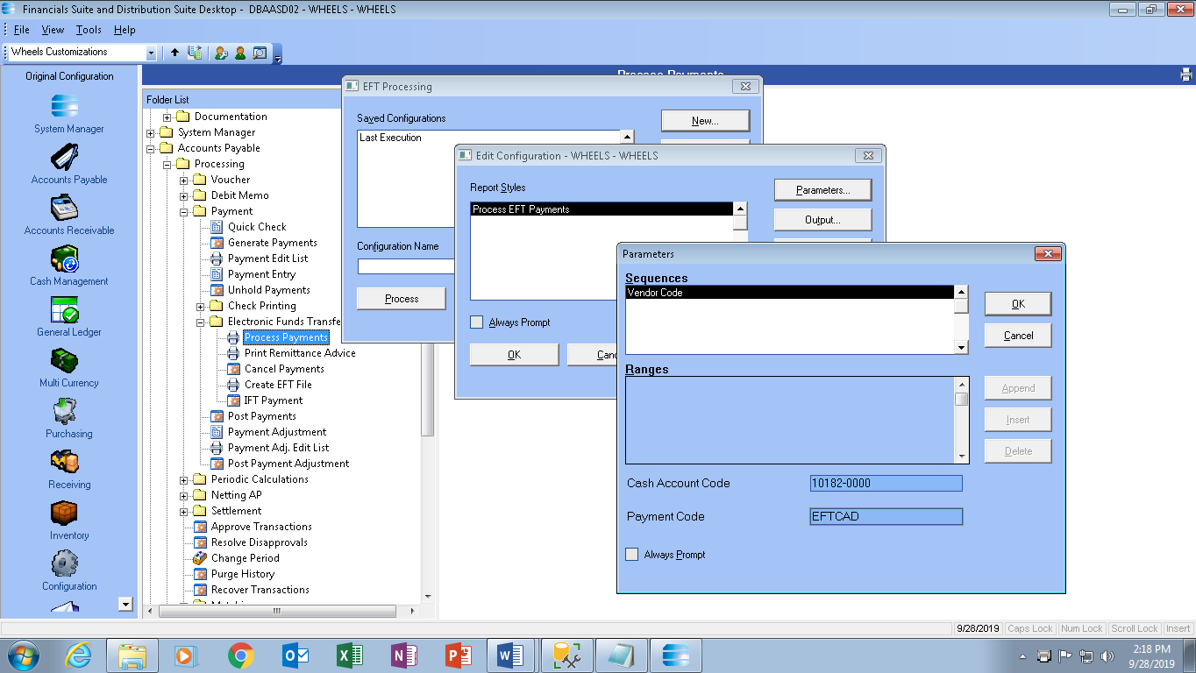

6.2.6 Review Error Listing Report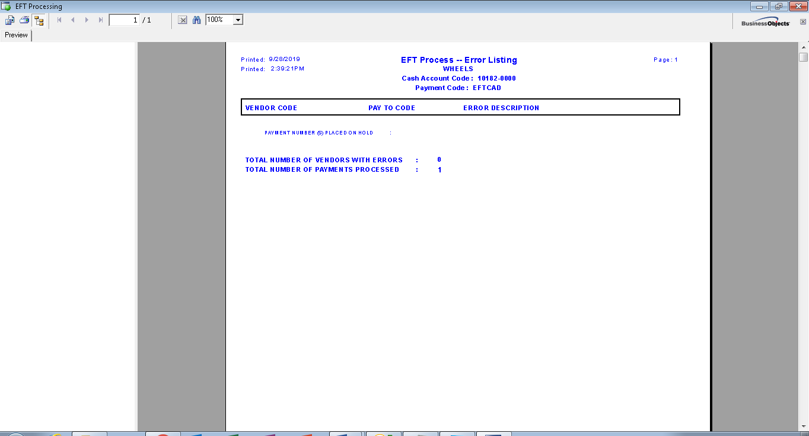

6.2.7 Open Create EFT file form. Select New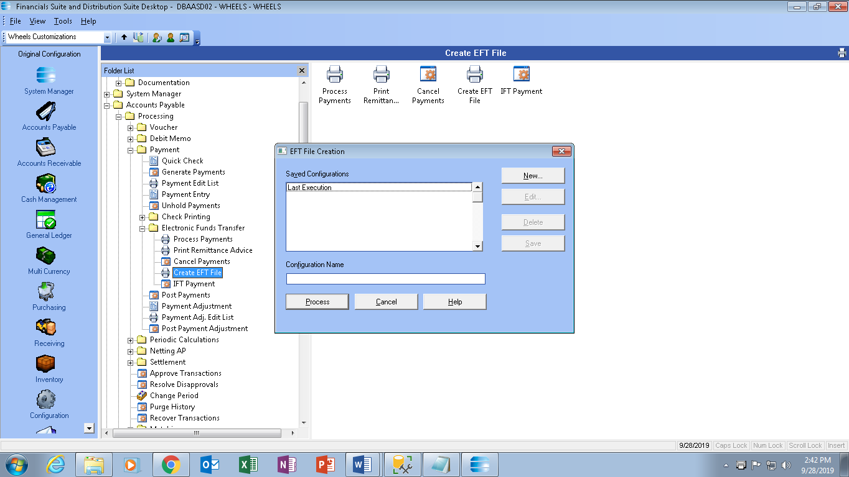

6.2.8 Enter **BMOCAD** asCash Account ,**EFTCAD** as Payment Code .Select File path and name . Use Processing Options form and enter Effective Entry Date (date on which funds are payable by bank ) . Click OK button and continue to Processing .

6.2.9 Review EFT File Creation Report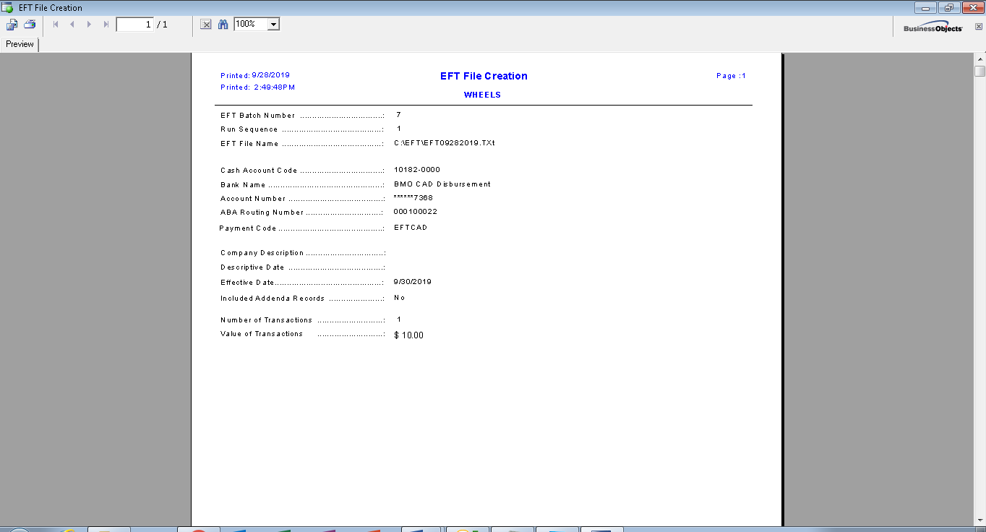

6.2.10 Open Print Remittance Advice . Select New. Select Summary style, Select Cash account for report range . Click OK and continue to Processing 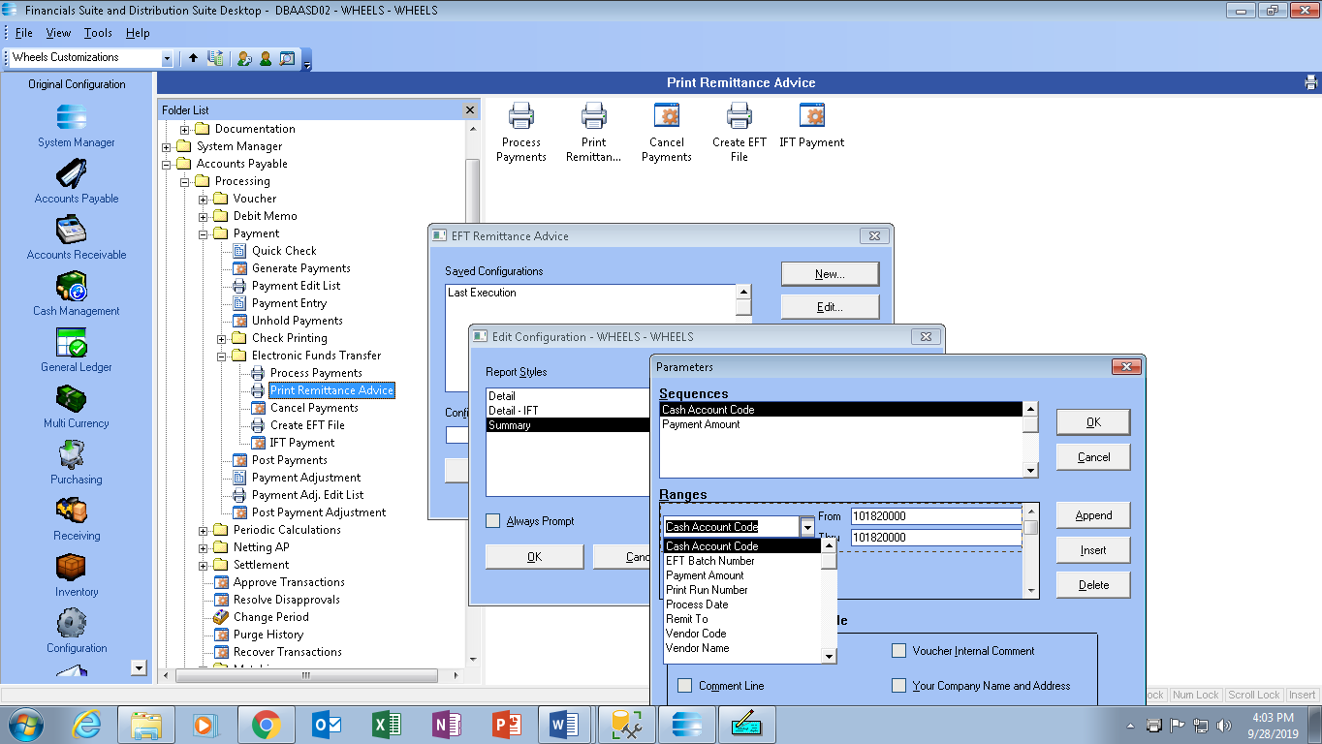

6.2.11 Review Remittance Advice Report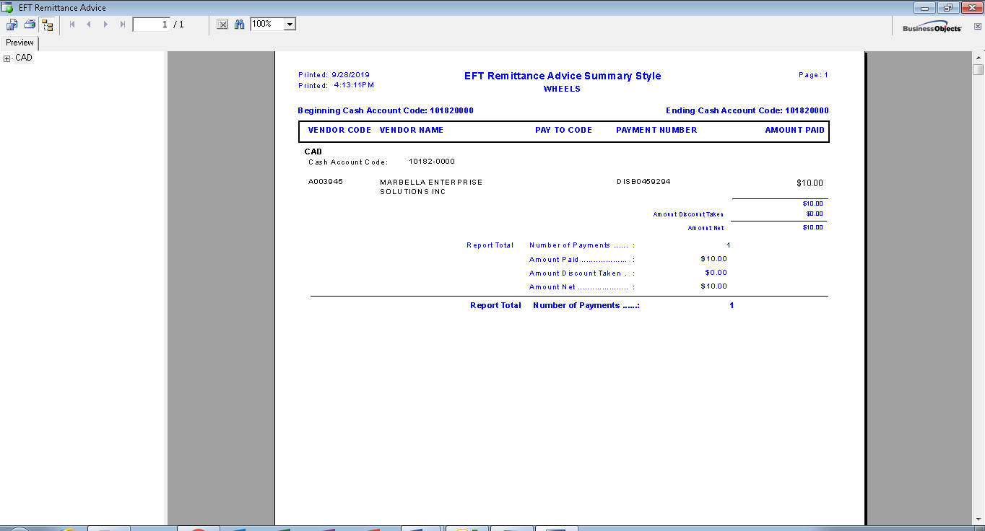

6.2.12 Transmit EFT file to bank using bank application. CHOOSE ***ACCOUNT INFORMATION*** TAB

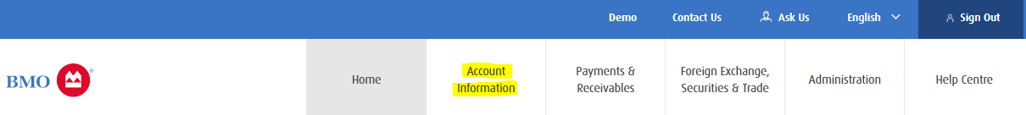

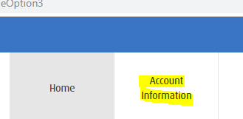

THEN UNDER ***FILE TRANSFER FACILITY***, CHOOSE ***SEND FILES***

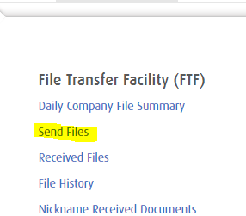

ON THE NEXT SCREEN, ***SEND FILE*** PAGE, ON THE ***PRODUCT*** DROP DOWN MENU, CHOOSE ***EFT***

ON THE ***DOCUMENT*** DROP DOWN MENU, CHOOSE ***BMO_EFT_80*** (THIS IS ACTUALLY THE ONLY PRODUCT AVAILABLE)

THEN ***FILE TO SEND***, CLICK THE BROWSE ICON AND GO TO BMO ISSUE FILE ON PUBLIC ON FIDO AND CHOOSE THE TEXT DOCUMENT YOU CREATED FOR YOUR PAYMENT



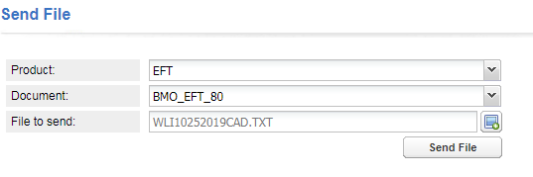

PRESS ***SEND FILE***.

6.2.12 After received confirmation from bank, proceed to Post Payment form. Enter disbursement number for control number .Post payments. This will trigger an automatic email to the vendor at 4:30 pm

## 6.3 CHEQUE RUN PROCEDURES

**CHEQUE RUN PROCEDUER FOR ACCOUNTS PAYABLE ADMIN CHEQUE RUN EVERY FRIDAY**

**FIRST MAKE SURE TO POST VOUCHERS!**

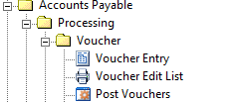

RUN AN AGING REPORT BY DATE 6 MONTHS PRIOR TO DUE DATE UPTO THE WEEKEND OF THE CHK RUN

**1.AGED PAYABLE REPORT**

ACCOUNTS PAYABLE- REPORTS-ANALYTICAL-AGED PAYABLES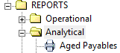

NEW - SUMMARY –PARAMETERS

**SEQUENCES**- VENDOR NAME

**RANGES**-

1.VENDOR CLASS: FROM: ADMIN

THRU: ADMIN

2.CURRENCY: FROM: CAD

THRU: CAD

3.DUE DATE: FROM: 01/01/17 (DATE AT LEAST 6 MONTHS TO A YEAR PRIOR)

THRU: CHEQUE DATE (DEPENDING ON THE DATE YOU ARE ALLOWED TO DO THE CHK RUN)

**AS OF DATE: 3/14/11 (SAME DATE AS THE THRU DATE**)

PRINT OPTIONS: HIGHLIGHT DUE DATE

OK, OK, OK, PROCESS

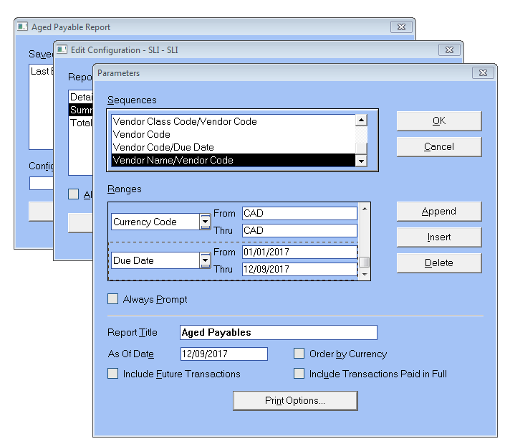

ONCE THE AGING COMES UP ON YOUR SCREEN CLICK ON THE EXPORT REPORT BUTTON ON THE LEFT HAND CORNER OF THE AGING

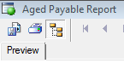

**FORMAT**: MICROSOFT EXCEL 97-2000 DATA ONLY (EXLS)

OK, OK AND SAVE ON WLI PUBLIC ON FIDO- AP INVOICES- CAD - FILE NAME

ON YOUR EXCEL SHEET, TITLE THE 1ST TAB AGING, THEN INSERT TWO MORE TABS-UNPOSTED & PYMT REG

**REVIEW QUICKLY AGING CHECK ADDRESS ON THE AGING WITH THE CANADIAN ADDRESS**

**(AUDIT WITH A PARTNER)**

IF THEY MATCH HIGHLIGHT THE WHOLE LINE IN YELLOW

IF INVOICES ARE MISSING COLOR THE LETTERING IN RED

IF INVOICES ARE TO BE DELETED FROM THE CHEQUE RUN HIGHLIGHT THE LETTERING IN RED AND PUT A COMMENT

**MAKE CHANGES CORRECTIONS AND UPDATE THE SPREADSHEET-**

IF THERE IS A WRONG INVOICE NUMBER/AMOUNT HIGHLIGHT THE LETTERING IN RED AND ADD A COMMENT AS TO WHAT IS WRONG WITH THE INVOICE WITH THE NAME OF THE PERSON. MAKE SURE NECESSARY CHANGES ARE MADE IN EPICOR AS WELL. DEBIT AND RE-ENTER WITH CORRECT INVOICE NUMBER.

**WIRES ARE RUN ONLY ON FRIDAYS, UNLESS URGENT WIRE REQUISITION IS RECEIVED AND APPROVED.**

PAYMENT REGISTER FOR CAD AND US WIRES AND GET THEM SIGNED BY LINDA. ONCE THEY ARE APPROVED YOU CAN ENTER THEM IN THE BANK. EMAIL A SIGNED COPY OF THE REGISTER TO DENISE .K and COPY JERRY/EMAD TO APPROVE.

**2.GENERATE PAYMENTS- CHEQUE RUN DONE ON FRIDAY**

PAYMENTS- GENERATE PAYMENTS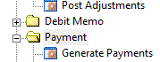

CASH ACCOUNT-PICK BMO-CAD FOR CAD CHEQUES AND BANK OF AMERICA FOR USD CHEQUES

VENDOR CLASS: FROM: ADMIN THRU: ADMIN (UNCHECK BOX)

DUE DATE: SAME DATES AS THE AGING DATE-FROM AND THROUGH TO THE CHEQUE DATE

STANDARD PAYMENT: SELECTED PAYEMENT METHOD-PAYMENT METHOD: **CHEQUE**

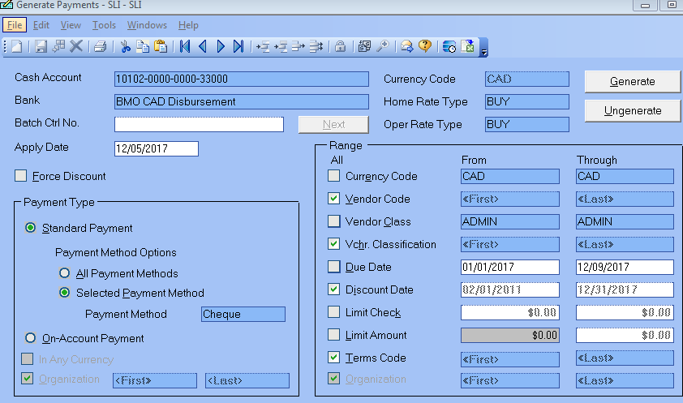

GENERATE

ALL CHEQUES COME INTO PAYMENT ENTRY

**3.UNPOSTED PAYMENT LISTING-**

REPORTS- OPERATIONAL-UNPOSTED-UNPOSTED PAYMENT LISTING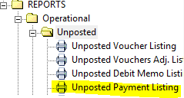

NEW-SUMMARY-PARAMETERS-RANGES

1. CASH ACCOUNT-BMO CAD OR BANK OF AMERICA
2. PAYEMENT METHOD: FROM: CHEQUE THROUGH: CHEQUE
3. VENDOR CLASS: FROM: ADMIN THROUGH: ADMIN
4. CURRENCY: FROM CAD THROUGH CAD OR USD THROUGH USD

OK, OK, PROCESS

CLICK ON THE EXPORT REPORT BUTTON ON THE TOP LEFT HAND CORNER

**FORMAT**: MICROSOFT EXCEL 97-2000 DATA ONLY (EXLS)

OK, OK AND SAVE ON PUBLIC ON FIDO- AP INVOICES- CAD/US CHK RUN- FILE NAME/SHEET 2

CHECK THE UNPOSTED PAYMENT LISITNG WITH THE TOTAL OF EACH VENDOR ON THE AGING.

HIGHLIGHT THE TOTAL OF EACH VENDOR (THE SECOND AMOUNT) ON THE AGING IN GREEN IF IT MATCHES AND IF THE AMOUNT HAS TO BE CHANGED MAKE NECESSARY CHANGES IN PAYMENT ENTRY AS WELL AS IN THE UNPOSTED PAYMENT REGISTER.

*THE TOTAL OF THE UNPOSTED PAYMENT REGISTER HAS TO MATCH THE TOTAL OF THE AGING*. IF BOTH TOTALS MATCH PRINT AN UNPOSTED PAYMENT REGISTER

**UPDATE PAYABLES BUDGET TEMPLATE- TUESDAY**

PUBLIC ON FIDO- AP INVOICES NEW TEMPLATE WEEKLY CHEQUE RUN

SAVE THE TEMPLATE

**SIGNATURE AND APPROVAL- FROM LINDA**

TAKE THE UNPOSTED PAYMENT REGISTER AND WIRE PAYMENT REGISTER TO LINDA FOR APPROVAL

PLEASE MAKE SURE YOU KNOW THE ENTIRE AMOUNT OF THE CHEQUE RUN OR PRINT A COPY OF THE TEMPLATE SO THAT LINDA KNOWS WE ARE WITHIN OUR BUDGET

AND GET IT APPROVED BY LINDA AND CHEQUES CAN BE PRINTED.GET THE USB KEY FROM LINDA.

**PRINT CHEQUES**

ACCOUNTS PAYABLE-PAYMENTS-CHEQUE PRINTING-PRINT MICR CHEQUES

NEW-CAD/US CHEQUES (**PICK THE RIGHT CHEQUES YOU ARE PRINTING**)-PARAMETERS-

SEQUENCES: VENDOR NAME

RANGES: VENDOR CLASS : FROM: ADMIN

THRO: ADMIN

CASH ACCOUNT: PICK BMO-CAD- CAD CHEQUES

OR BANK OF AMERICA-US CHEQUES

OK, OK, PROCESS

PRINTING FROM CHEQUE # ---- FROM BANK ACCOUNT- OK

CHOOSE PRINTER: PICK CPS PAYSTATION (LEFT CORNER OF THE PAGE SECOND ICON)

OK

PUT THE KEY INTO THE COMPUTER

ENTER NAME AND PASSWORD

PICK THE RIGHT CHEQUES BMO-CAD DISPURSEMENT -* **VERY IMPORTANT\***

**SLIBOMCA** PAYSTATION FOR CAD LOGISTICS

**WLIBOA** PAYSTATION FOR USD LOGISTICS

PRINT

WAIT FOR ALL CHEQUES TO PRINT. CHECK ALL THE CHEQUES INDIVIDUALLY TO MAKE SURE THEY ARE PRINTED WITHOUT ERRORS.

CHEQUES PRINTED SUCCESSFULLY: YES

LOG OFF

BEFORE YOU POST PAYMENTS, RUN AN UNPOSTED PAYMENT REPORT ONCE MORE TO SHOW THE CHEQUE NUMBERS.

EXPORT THIS TO EXCEL AND PASTE UNDER YOUR ORIGINAL UNPOSTED WITH NO CHEQUE NUMBERS, AND PRINT THIS REPORT AS WELL

**POST PAYMENTS**

ACCOUNTS PAYABLE-PAYMENT-POST PAYMENT

UNDER DOCUMENT NUMBER- DOUBLE CLICK FROM: PICK THE BEGINNING CHEQUE NUMBER

TO: PICK THE LAST CHEQUE NUMBER

POST

**PAYMENT REGISTER**

ACCOUNTS PAYABLE-REPORTS-OPERATIONAL-PAYMENT REGISTER

NEW-SUMMARY-PARAMETERS

RANGES

CURRENCY CODE: CAD/US

PAYMENT DATE: THE DATE THE CHK IS PRINTED

VENDOR CLASS: WHEELS

OK, OK, PROCESS

PRINT THIS REGISTER. THIS REGISTER HAS TO MATCH WITH THE UNPOSTED PAYMENT LISTING. ATTACH IT WITH ALL THE CHEQUES TO BE FILED.

**SCAN CHEQUES-IN THE SCANNING DEPT SCANNER**

CHANGE IT TO SYSCHQ

SCAN F2

DEPOSIT DATE : MM/DD/YYYY

BUSINESS TYPE: ADMIN

ACCOUNT TYPE: AP

CHEQUE TYPE: CHEQUE

BANK A/C : BMO CAD

CURRENCY: CAD

**CAD UPLOAD TO THE BANK- SHOULD BE DONE BEFORE 3.45PM ON THE DAY THE CHEQUES ARE RUN**

PRINT A PAYMENT REGISTER FOR THE CHEQUES RUN ADMIN AND TRADE

REPORTS-OPERATIONAL-PAYMENT REGISTER-NEW-SUMMARY-PARAMETERS

SEQUENCES-CHK /DOC NO

RANGES: CURRENCY CODE: CAD

PAYMENT METHOD: CHEQUES

PAYMENT DATE: FROM THE BEGINNING TO THE END OF THE WEEK

OK OK PROCESS

PRINT THE REGISTER

DCH UPLOAD

AP/PROCESSING/PAYMENT/ CHECK PRINTING/ DCH EXPORT

CASH ACCOUNT: BMO CAD

PATH/FILE NAME: CLICK ON BROWSE

GO TO BMO ISSUE FILE ON CAMIS/WLI/2013(CAD)

TYPE IN WILMMDDYYYYCA.TXT

SAVE

CLICK ON OK AND WAIT **DO NOT CLICK TWICE OR THE FILES DISAPPEARS**

WAIT, THE HOUR GLASS SHOWS IT IS PROCESSING, IT TAKES A FEW MINUTES

IT GIVES YOU A NUMBER, WRITE THE NUMBER ON TOP OF THE PAYMENT REGISTER

OK- TO THE MESSAGE

CLICK ON VIEW AND SEE IF THE TOTAL ON THE EXPORT MATCHES THE PYMT REGISTER

CLICK ON THE **X** AND CLOSE. **DO NOT CLICK OK OR THE FILE DISAPPEARS**

BMO: ACCOUNT INFORMATION/FILE TRANSFER FACILITY/SEND FILESPRODUCT: DCS DOCUMENT: DCS_ISSUE_FILE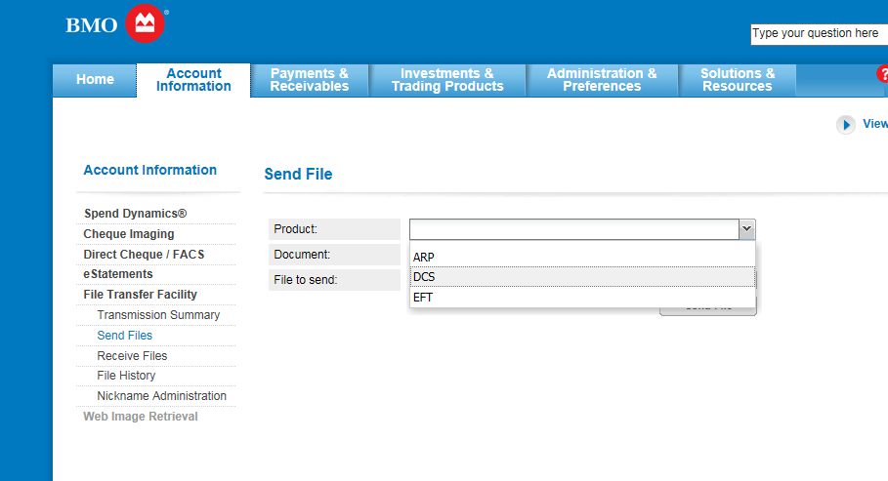

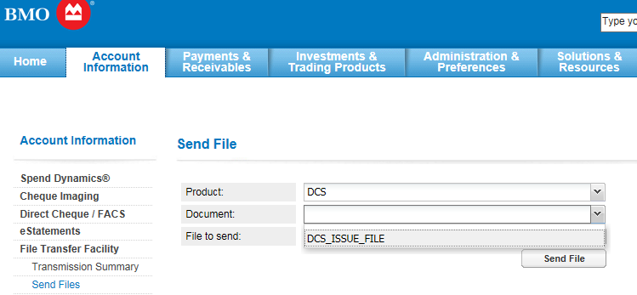

FILE TO SEND: CLICK ON BROWSE AND GO TO BMO ISSUE FILE ON CAMIS/WLI/2013 AND CHOOSE THE FILE YOU JUST SAVED AND OPEN

SEND FILE

PASSWORD: APTEAM AND THE NUMBERS ON THE TOKEN OF THE BMO BANK



AFTER SEVERAL MINUTES YOU WILL RECEIVE THIS REPORT:

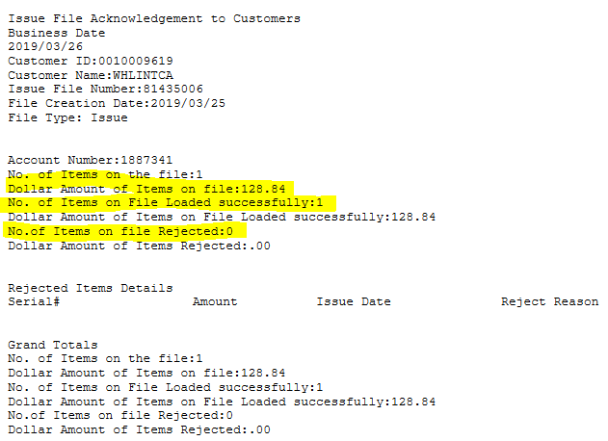

REFRESH: TILL STATUS SHOWS COMPLTE. PRINT

GO TO RECEIVE FILES ON TOP AND VIEW.

MAKE SURE THE AMOUNT MATCHES WITH WHAT IS ON YOUR PAYMENT REGISTER. PRINT AND LOG OFF.

## 6.4 HOW TO DO A PAYMENT ENTRY

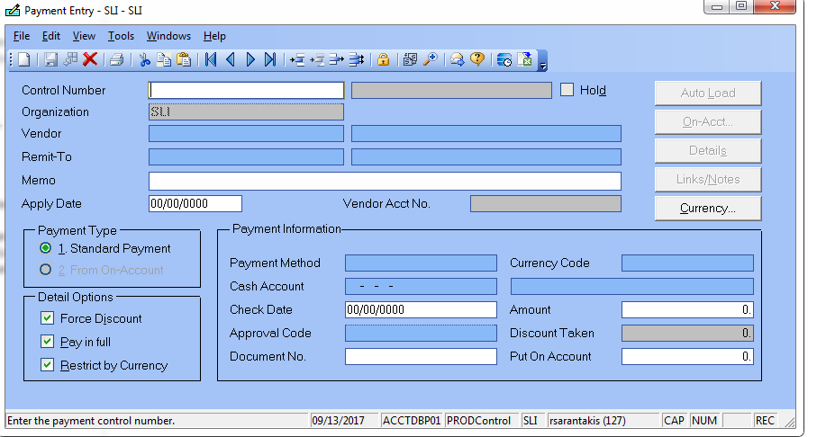

STEP ONE: CLICK NEW (UNDER FILE)

COPY AND PASTE VENDOR CODE IN VENDOR BOX THEN PRESS TAB AND IT WILL SHOW VENDOR

IT WILL LOOK LIKE THIS: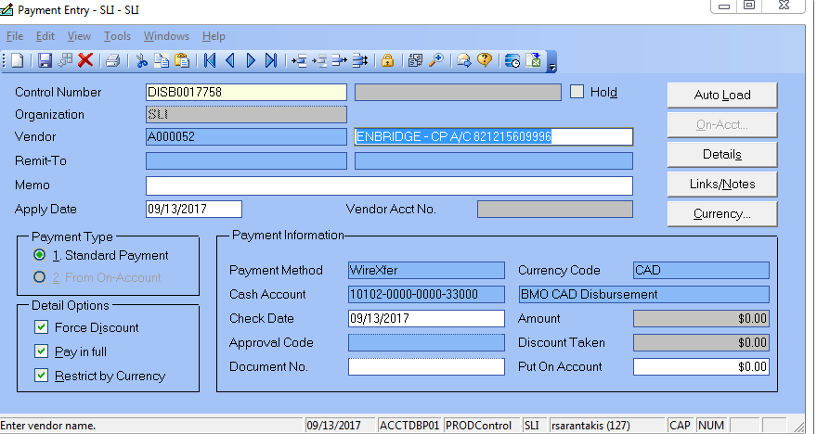

CHANGE APPLY DATE AND CHECK DATE TO THE DATE THE MONEY CAME OUT OF THE BANK

AUTO LOAD

THEN PRESS AUTO LOAD THIS WILL PULL ALL O/S POSTED VOUCHERS

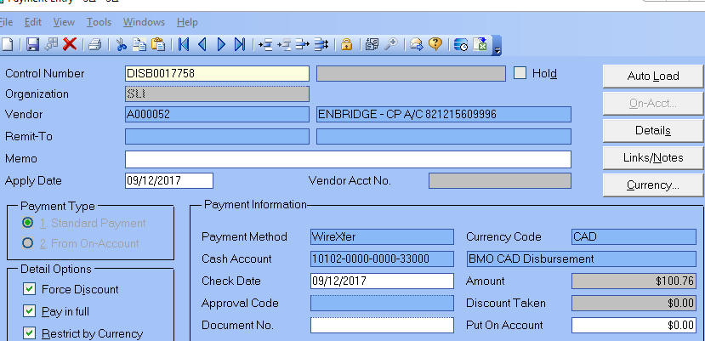

THEN SAVE PAYMENT

THEN POST PAYMENTS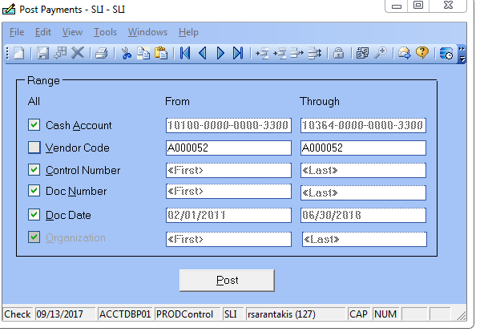

YOU WILL GET A SCREEN THAT LOOKS LIKE THIS: 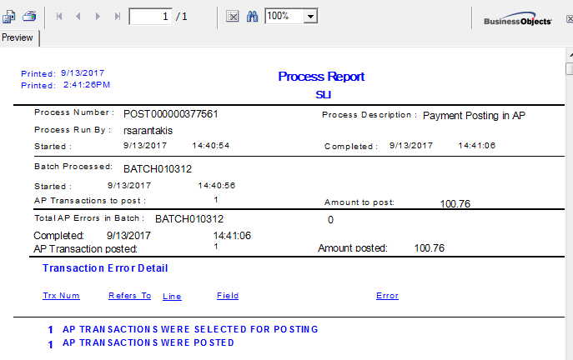

MAKE SURE THERE ARE NO ERRORS AND CHECK AMOUNT

THEN GO TO REPORTS-OPERATIONAL-POSTED-PAYMENT REGISTER

PRESS NEW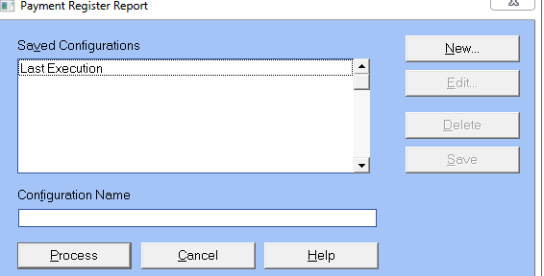

REPORT STYLES: SUMMARY

THEN PRESS PARAMETERS. SEQUENCES-GO BY CHECK/DOC NO.

RANGES ARE:

1. CASH ACCOUNT BMO CAD DISPURSEMENT
2. CURRENCY (CAD OR USD)
3. PAYMENT DATE
4. PAYMENT METHOD (WIRE)
5. VENDOR CLASS-ADMIN
6. AND YOU COULD DO VENDOR CODE

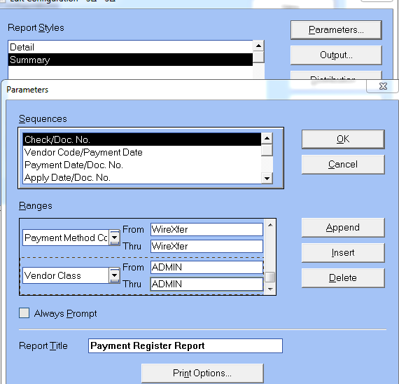

**PRESS OK, OK AND PROCESS**

## 6.5 HOW TO DO A STOP PAYMENT

1.EPICOR-PAYMENT ADJUSTMENT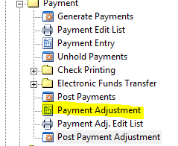

PRESS NEW-WRITE DOWN CONTROL # THEN ENTER VENDOR NUMBER, DOUBLE CLICK AND CHOOSE YOUR CORRECT VENDOR. THEN ENTER YOUR DOCUMENT NUMBER (CHEQUE #) AND DOUBLE CLICK TO CHOOSE THE CORRECT CHEQUE.

IN ADJUSTMENT OPTIONS, CHOOSE OPTION # 3-VOID PAYMENT.

THEN EXPLAIN THE SITUATION IN LINKS AND NOTES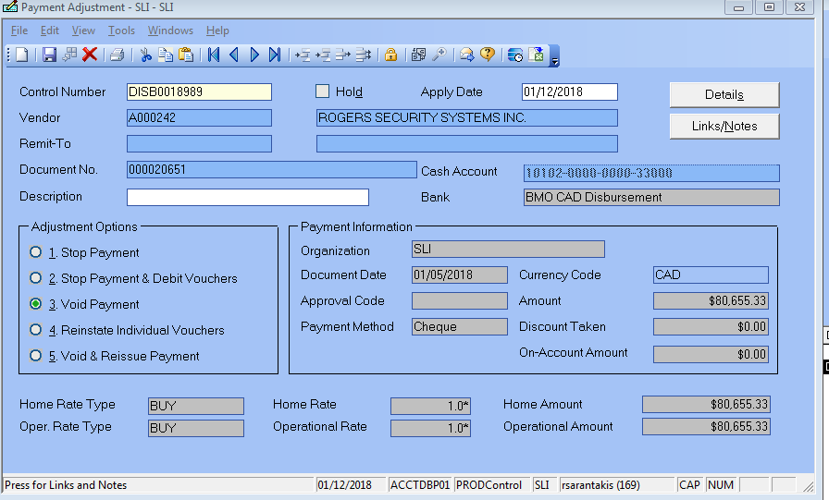

THEN YOU MUST **POST PAYMENT ADJUSTMENT**

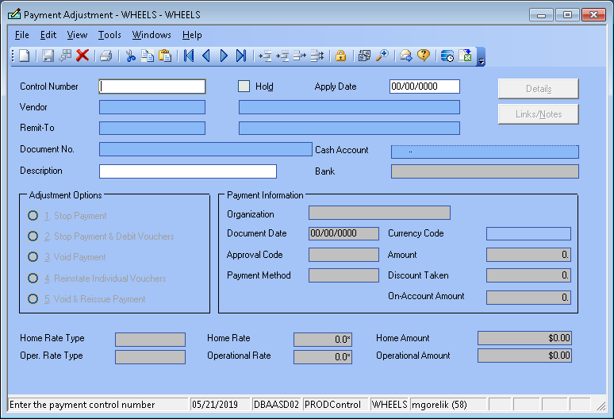

**Stop Payment**

When you choose this option, the system voids the payment, changes

vouchers on the payment to a status of “not paid” (so they can later be paid by another payment),

and creates a GL transaction that credits the

cash account and debits a bank charge account defined in the Cash

Account record for a bank charge amount also defined in the Cash

Account record.

**Void Payment**

When you choose this option, the system completes the same tasks as

outlined for *Stop Payment*, only the GL transaction for a stop payment

charge is not created.

**Stop Payment & Debit Vouchers**

When you choose this option, the system completes the same tasks as

outlined for *Stop Payment*. Additionally, the system creates debit memos

that apply to the vouchers, essentially “canceling” the vouchers that were

to be paid. The system creates the debit memos on hold. You then need

to release the debit memos from hold and post them in order to cancel

the vouchers.

**Reinstate Individual Vouchers**

When you choose this option, you can open the Payment Adjustment

Details window and void payment on specific vouchers. For example, if

a payment applies to three vouchers and you want it to apply to only two

of them, you can void one of the vouchers. The amount that had been

applied to the voucher is instead placed on account and the voided

voucher’s status is changed to “not paid.” The voucher is reinstated.

**Void & Reissue Payment**

When you choose this option, the system voids the selected payment, then reissues a duplicate unposted payment. You may want to use this option, for example, in cases when a check is accidentally damaged.

2. **BANK PORTION**-SIGN IN TO BMO, CLICK ON DIGITAL CHEQUE SERVCICES FROM THE DROP DOWN. CHOOSE SEARCH TO VERIFY THE CHEQUE HAS NOT BEEN CASHED

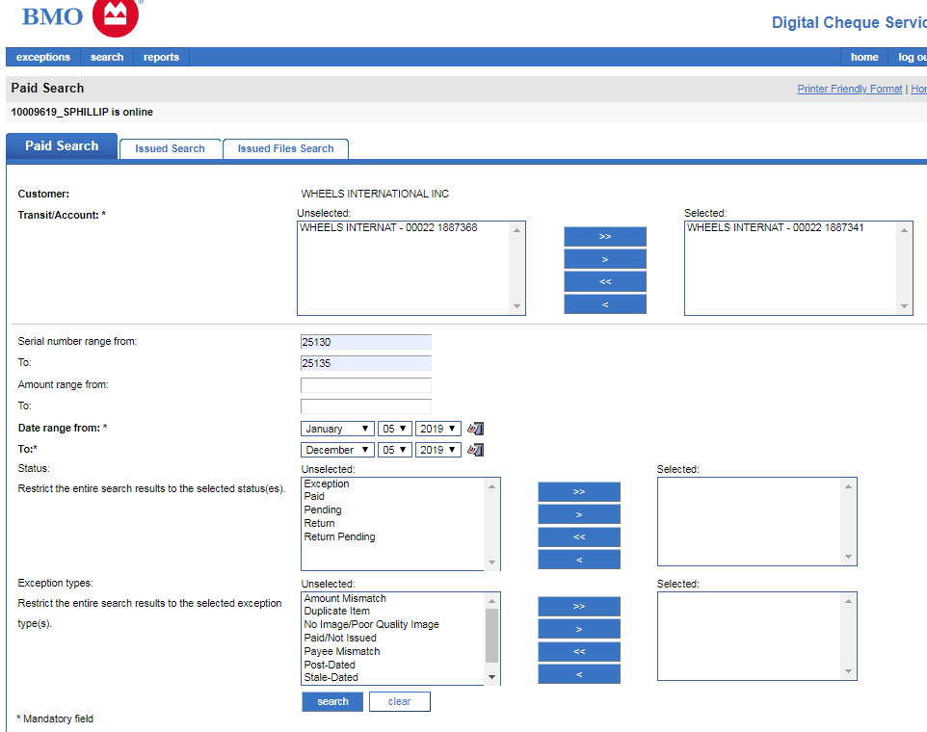

CHOOSE YOUR ACCOUNT, YOUR SERIAL NUMBER RANGE FROM AND TO AND DATE RANGE THEN CLICK SEARCH

THEN YOU GET THIS SCREEN THAT SHOW YOUR PAID SEARCH RESULTS

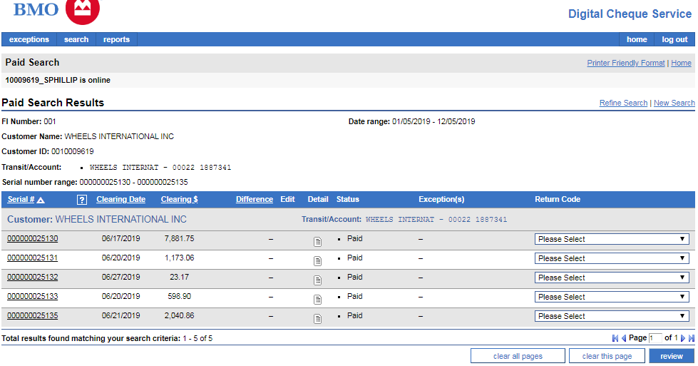

IF YOUR CHEQUE IS OUTSTANDING YOU WILL GET A SCREEN THAT LOOKS LIKE THIS:

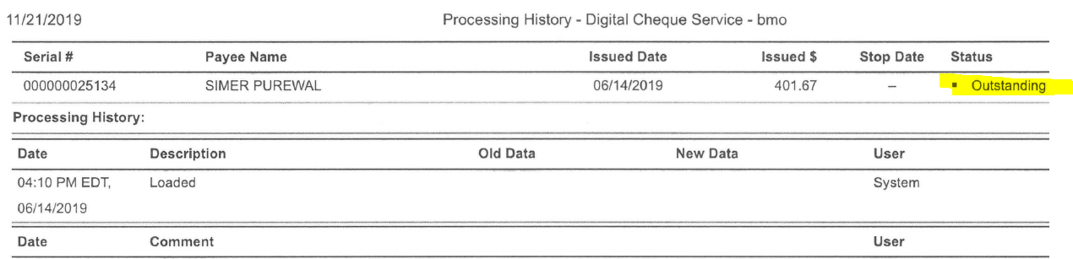

THEN YOU CHOOSE THE PAYMENTS & RECEIVABLES TAB AND FOLLOW BELOW INSTRUCTIONS

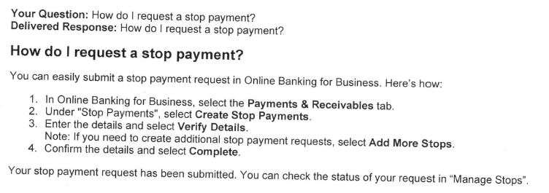

GST AND QST REMITTANCE BMO ONLINE SCREEN SHOT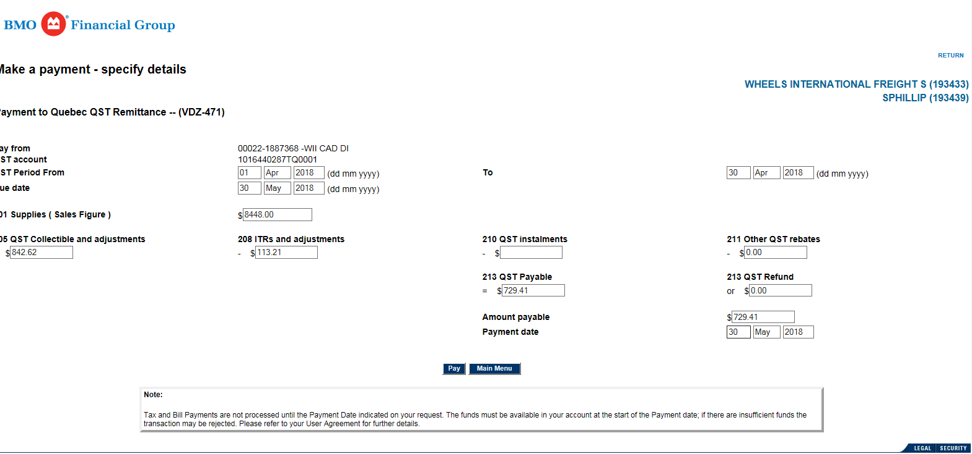

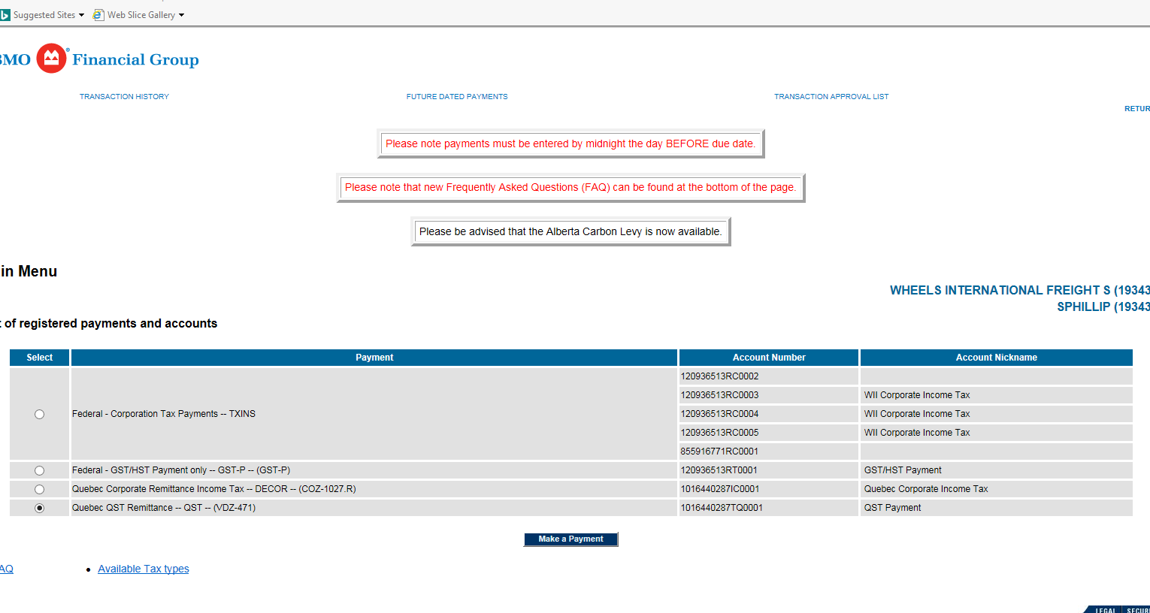

TRANSPORTATION TRAINING NOTES BELL VENDOR A004602

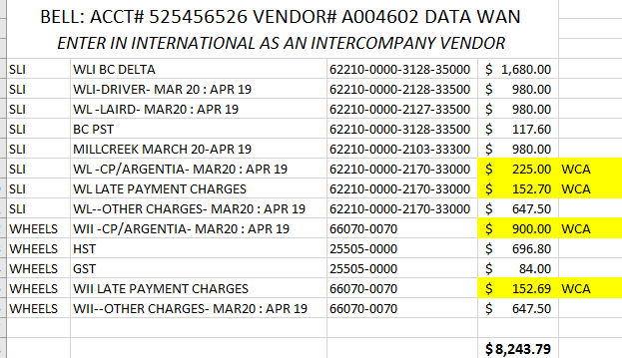

## PROCESSING MASTERCARDS

LIST OF PEOPLE WITH MASTERCARDS:

|  |  |  |  |
| --- | --- | --- | --- |
| MARK LIPINSKI | INTERNATIONAL | 5569 0900 0385 6021 | AMC004986 |
| STEVE KOYANAGI | INTERNATIONAL | 5569 0900 0294 3226 | AMC004784 |
| LAURIE FOX | INTERNATIONAL | 5569 0900 0369 3028 | AMC004807 |
| ~~JASON MUSCAT~~ | ~~INTERNATIONAL~~ | ~~5569 0900 3036~~ |  |
| ~~GURMIT BOURQUE~~ | ~~INTERNATIONAL~~ | ~~5569 0900 0369 3044~~ | ~~AMC004809~~ |
| MATTHEW BOURQUE | INTERNATIONAL | XXXX-XXXX-XXXX-2846 | AMC005070 |
| LINDA MCNEIL | INTERNATIONAL | XXXX-XXXX-XXXX-4396 | AMC005144 |

|  |  |  |  |
| --- | --- | --- | --- |
| ZENOBIA D’SOUZA | LOGISTICS | 5569 0900 0378 4777 | AMC000304 |

**INTERNATIONAL**

1. MARK LIPINSKI (EXPENSE REPORT Prepared by Rachna) AUTHORIZED BY HARRY SMIT
2. STEVE KOYANAGI AUTHORIZED BY JASON
3. LAURIE **(**DO NOT EMAIL LAURIE) AUTHORIZED BY IAN
4. ~~JASON AUTHORIZED BY IAN~~
5. MATTHEW BURQUE AUTHORIZED BY HARRY SMIT
6. LINDA (DO NOT EMAIL LINDA) AUTHORIZED BY LAURIE FOX

**LOGISTICS**

1. ZENOBIA AUTHORIZED BY CRAIG

**Linda does not submit expense report-she just gives the statement and it is approved Linda and Laurie and receipts are at the back**

On the 27th or 28th of each month, the mastercard statements get posted on the website. Bhavna will then email the statements to admin.

I then forward it to each person (minus Laurie and Linda) and copy admin

The employees are supposed to submit an expense report with receipts and photo copies and approved within 30 days

It is the same procedure as personal expense reports

Then you enter regular expense report under their MC vendor

Emad will email to apply payments (create wire payment entry)

Print 2 copies of Emad’s email (WII, WLI,)

Make sure all vouchers are approved, taken off hold, and posted first.

Then do payment register, Ketan signs, then scan, index and box in a separate MC box

When the voucher is on HOLD waiting for approval or whatever else, but it is due for payment, you must put it ON ACCOUNT and apply it later.

## 6.7 BMO SCREENSHOTS FOR ONLINE BANKING-PAYING BILLS

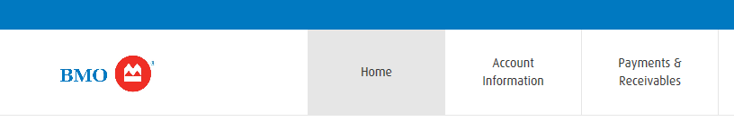

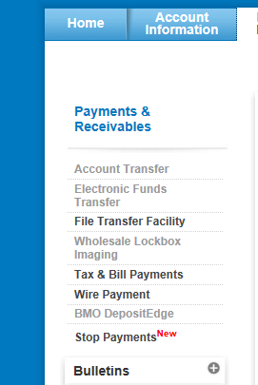

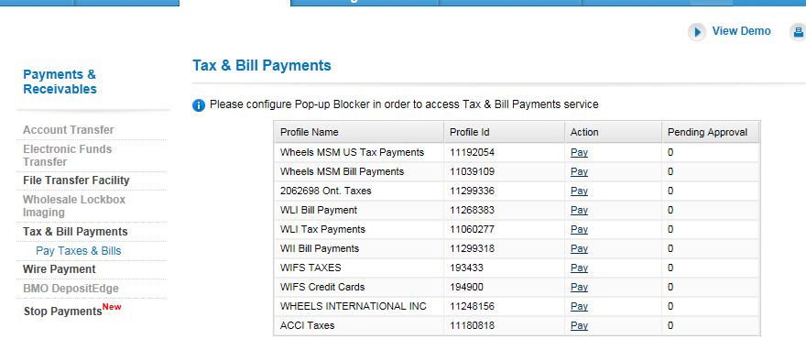

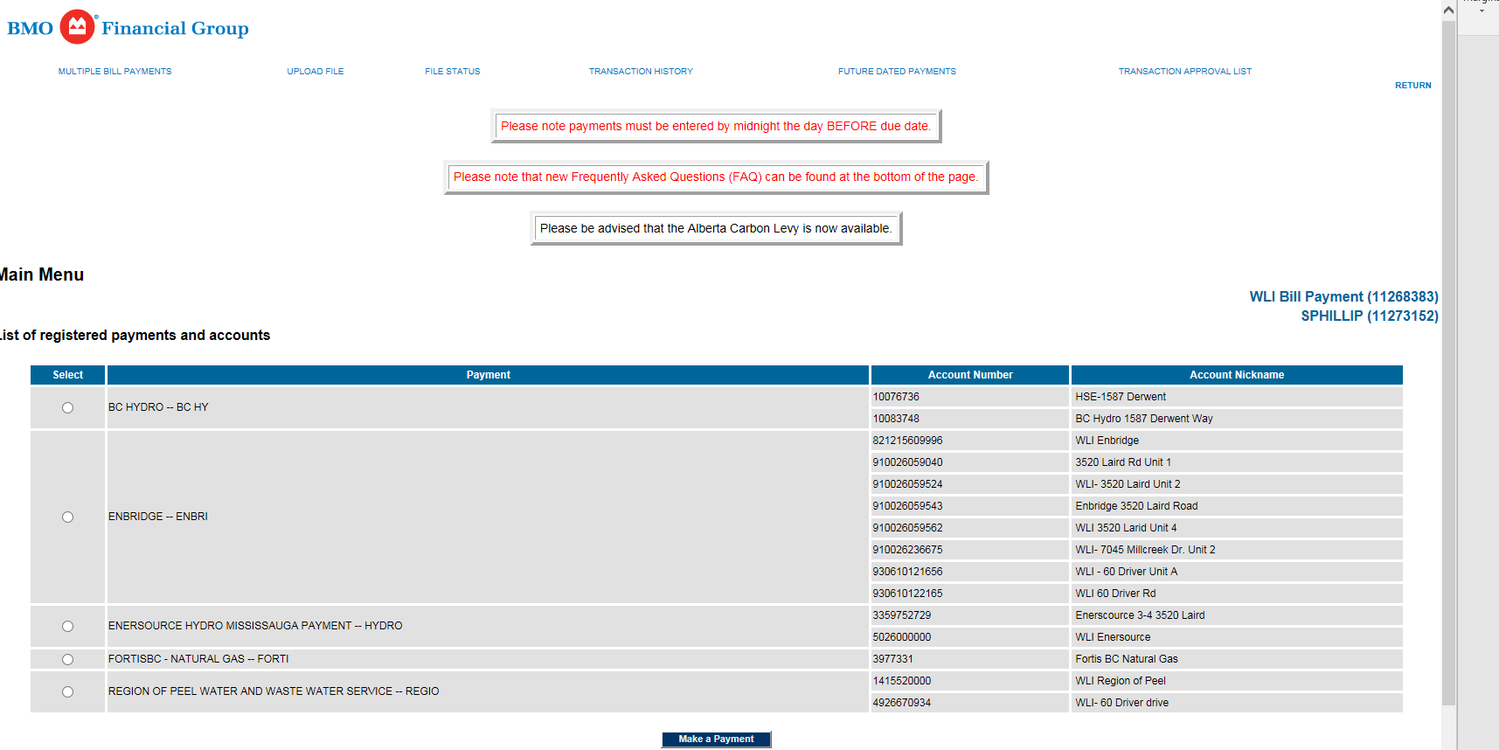

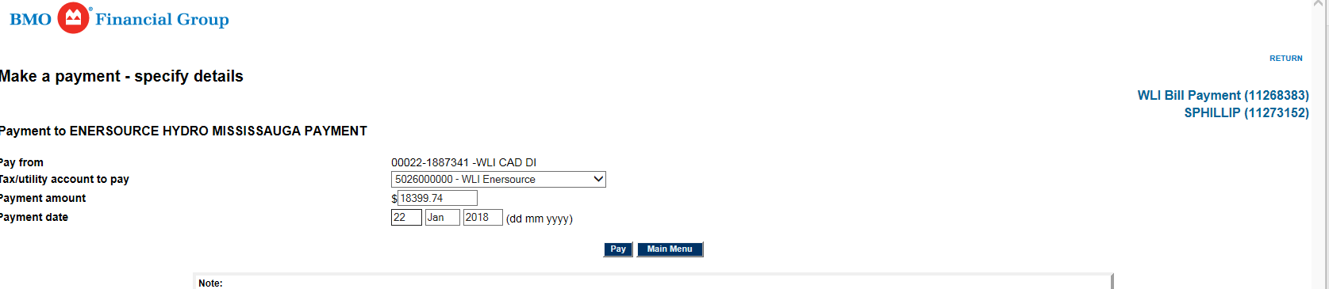

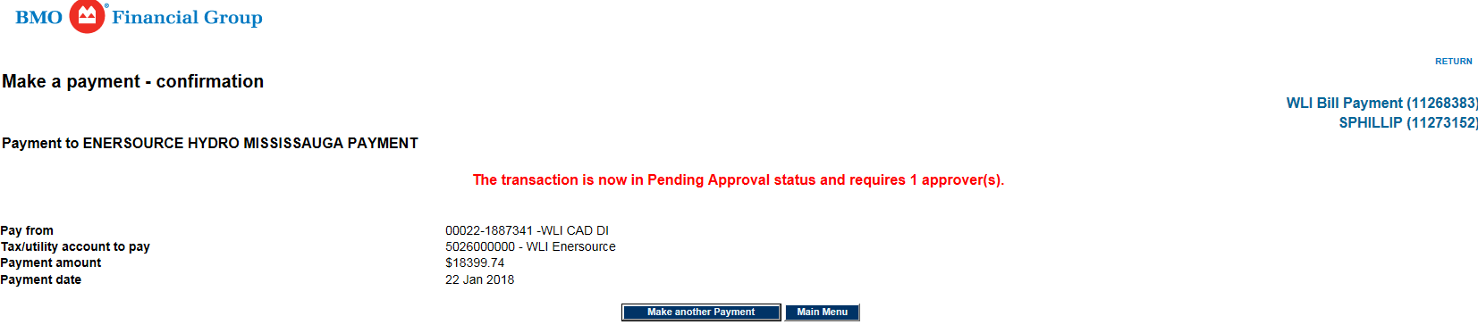

## 6.8 VOUCHER ADJUSTMENT AND REVIEW POSTED VOUCHER

TO CHANGE THE DUE DATE ONY ON A POSTED VOUCHER YOU DO A VOUCHER ADJUSTMENT ENTRY

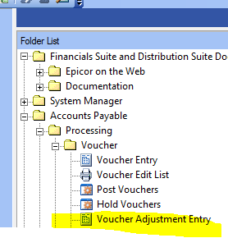FROM HERE CLICK NEW, ENTER THE VOUCHER# YOU WANT TO ADJUST. CHANGE DUE DATE AND SAVE AND BE SURE TO POST YOUR ADJUSTMENT

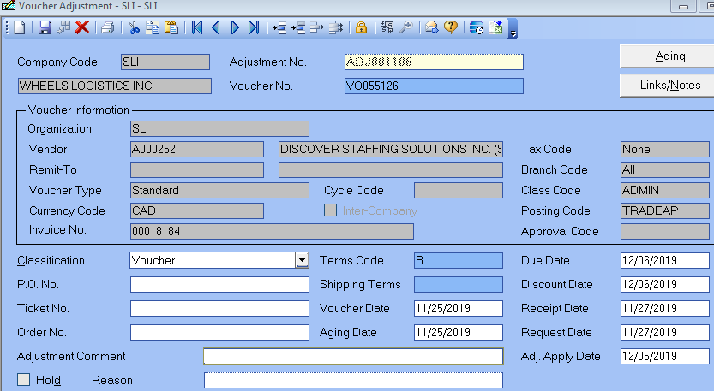

THERE IS ALSO AN OPTION TO CORRECT AN INVOICE NUMBER IT IS CALLED REVIEW POSTED VOUCHER

NO NEED TO POST THIS ONE. 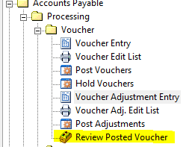

## 6.9 BILL AND PAY SLI TRADE NOTES

THESE ARE INVOICES FROM VENDORS THAT WE ARE BILLING BACK DIRECTLY TO THE CUSTOMER

THESE ARE ENTERED IN SLI BUT THE VENDOR CLASS IS TRADE AND NOT ADMIN

MOSTLY THEY ARE COURIER VENDORS BUT ALSO SUPPLIES AND OR SERVICES

ANNA FIGLIOMENI IS THE MANAGER OF CUSTOMER SERVICE AND SHE WILL BE APPROVING MOST INVOICES

SHE WILL ALSO HAVE THE FINAL SAY ON IF A SUPPLY IS TO BE BILLED BACK TO A CUSTOMER OR NOT

FOR EXAMPLE, SOMETIMES THE DISTRIBUTION MANAGER WILL EMAIL THEIR APPROVAL AND SAY THIS MUST

BE BILLED BACK TO A CUSTOMER

IN THESE CASES YOU CAN'T JUST ASSUME THEY ARE CORRECT. YOU WILL FORWARD THE INVOICE AND THEIR EMAIL

TO ANNA AND ASK IF IT'S TO BE BILLED BACK OR NOT

ALL THESE VOUCHERS ARE CREATED AS ACCRUAL TYPE VOUCHERS.

SOME INVOICES, THE VOUCHER WILL BE CREATED BY INVOICING.

INVOICING WILL EMAIL US THE VOUCHER NUMBER AND THEN WE AS AP NEED TO

GO INTO THE VOUCHER, CORRECT IF NECESSARY THE INVOICE NUMBER, INVOICE DATE,

ADD HST IF NECESSARY, DOUBLE CHECK THE DATES AND CHANGE VOUCHER TYPE TO STANDARD

TAKE OFF HOLD AND MAKE SURE THE INVOICE DUE DATE COMES OFF IN TIME TO PAY THE VENDOR

REQUEST DATE: IS STARTING DATE OF SHIPMENTS. RECEIPT DATE IS LAST DAY OF SHIPMENTS

THEN YOU FORWARD THE EMAIL WITH THE VOUCHER # AND INVOICE ATTACHMENT TO

[WLCARGOW.BODY@radiantdelivers.com](mailto:WLCARGOW.BODY@radiantdelivers.com)

THIS IS THE SCANNING AND INDEXING TEAM. THEY WILL INDEX THE VOUCHER IN TRANSFLO TO WLCARGOW

**\*\*\*IMPORTANT: THE EMAIL TO WLCARGOW MUST BE IN PLAIN TEXT FORMAT NOT HTML OR IT WILL GET RETURNED\*\*\***

FOR ALL LOGISTICS TRADE VOUCHERS THAT YOU CREATE (NOT INVOICING), KEEP IN MIND THESE 4 THINGS:

1 ACCRUAL TYPE

2 TEDS REASON-COST ALLOCATION

3 EMAIL TO WLCARGO BODY IN PLAIN TEXT FORMAT (EXCEPT DHL, ANY EXCEL SHEETS AND THE LARGE PUROLATOR)

4 WAIT ONE DAY TO TAKE OFF HOLD, CHANGE IT TO STANDARD TYPE VOUCHER

**TEDS CHANGE REASON-DOUBLE CLICK AND CHOOSE COST ALLOCATION**

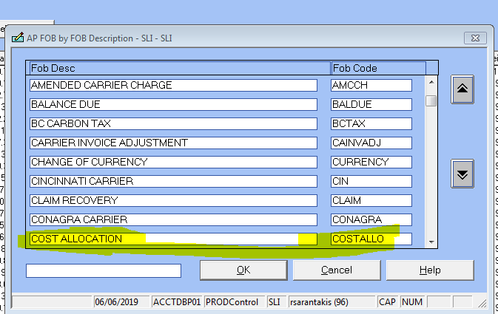

**ITEM CODE**

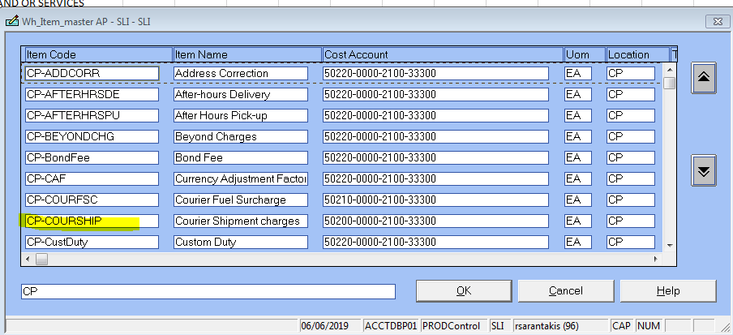

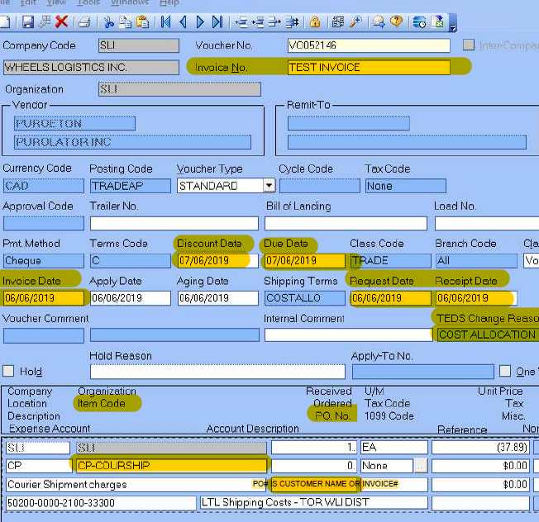



|  |  |  |  |  |  |  |  |  |  |
| --- | --- | --- | --- | --- | --- | --- | --- | --- | --- |
| **COURIERS:** | |  |  |  |  |  |  |  |  |
| EVERY WEEK THERE SHOULD BE 1 LARGE INVOICE TO PAY FROM PUROLATOR | | | | | | | |  |  |
| **ACCOUNT# 1230463** | |  | **VENDOR CODE: PUROETON** | | |  |  |  |  |
|  |  |  |  |  |  |  |  |  |  |
| JERRY WILL EMAIL YOU THE INFORMATION TO PAY THIS INVOICE WEEKLY | | | | | | |  |  |  |
| THE VOUCHER NUMBER WILL BE ON THE EXCEL SHEET. | | | | |  |  |  |  |  |
| IT WILL NEVER MATCH THE INVOICE AMOUNT | | | | |  |  |  |  |  |
| PRINT HIS EMAIL AND THE EXCEL SHEET | | | |  |  |  |  |  |  |
| LOG INTO PUROLATOR BILLING WEBSITE AND PRINT THE FIRST PAGE OF THE INVOICE | | | | | | | |  |  |
| PRINT 2 COPIES: 1 FOR AUDITING THE CHEQUE RUN, ONE FOR SCANNING | | | | | | |  |  |  |
| ON THE EXCEL SHEET IT WILL SAY ADDITIONAL ACCRUAL: INVOICE (DEBIT MEMO) TO BE CREATED | | | | | | | | |  |
|  | *DB-CREATE ADDITIONAL LINE, POSITIVE LINE WITHIN THE SAME VOUCHER | | | | | | | |  |
| AFTER THAT ADJUSTMENT, THE AMOUNT SHOULD MATCH WITH THE INVOICE | | | | | | | |  |  |
| IF THE ADDITIONAL ACCRUAL AMOUNT IS NEGATIVE, YOU ENTER A NEGATIVE AMOUNT | | | | | | | | |  |
| THERE COULD BE 2 VOUCHERS FOR THE SAME INVOICE-IN THAT CASE YOU MAKE THE ADJUSTMENT | | | | | | | | | |
| TO EITHER VOUCHER | |  |  |  |  |  |  |  |  |
| YOU INSERT A DETAIL LINE, IDTEM CODE TYPE IN CPCOURSHIP | | | | | |  |  |  |  |
| GL IS 50200-0000-2100-33300 | | | (LOOK AT EXCEL SHEET) | | |  |  |  |  |
| FOR THIS INVOICE, YOU DO NOT EMAIL SCANNING | | | | |  |  |  |  |  |
|  |  |  |  |  |  |  |  |  |  |
| YOU WRITE THE VOUCHER # ON BOTH COPIES OF THE INVOICE | | | | | |  |  |  |  |
| ONE YOU KEEP FOR AUDITING | | |  |  |  |  |  |  |  |
| THE OTHER INVOICE COPY YOU ALSO WRITE INX ON IT | | | | |  |  |  |  |  |
| AND STAPLE IT TO THE JERRY'S EMAIL AND THE EXCEL SHEET AND PUT IT IN THE SCANNING FOLDER | | | | | | | | | |
| THAT IS ON HANNAH'S DESK | | |  |  |  |  |  |  |  |

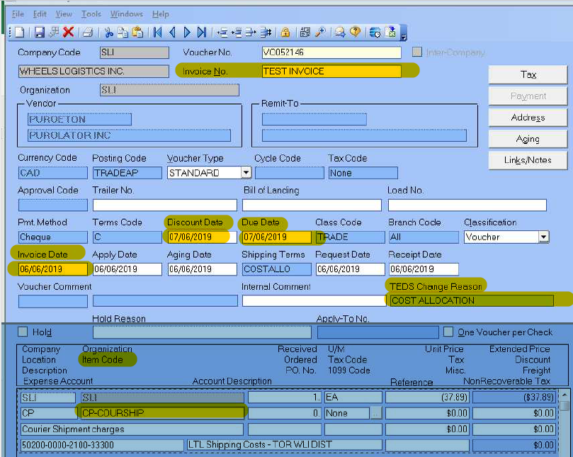

|  |  |  |  |  |  |  |  |  |  |  |  |  |  |  |  |  |  |
| --- | --- | --- | --- | --- | --- | --- | --- | --- | --- | --- | --- | --- | --- | --- | --- | --- | --- |
|  |  | |  | | |  |  |  | |  | |  | |  | |  | |
| ALL OF THE REST OF THE PUROLATOR ACCOUNTS, INVOICING WILL EMAIL YOU THE VOUCHER AND YOU | | | | | | | | | | | | | | | | | |
| JUST DOUBLE CHECK | | |  | | |  |  |  | |  | |  | |  | |  | |
| THE USUAL: INVOICE#, INVOICE DATE, REQUEST DATE, RECEIPT DATE, DUE DATE, HST AND TOTAL. | | | | | | | | | | | | | | | | | |
| ***\*\*\*\* INVOICING WILL NOT BE ADDING HST\*\*\*\**** | | | | | | | |  | |  | |  | |  | |  | |
| IF THE INVOICE HAS HST, YOU MUST ENTER A SEPARATE LINE AS ALWAYS GL 27015-0000-0000-33000 | | | | | | | | | | | | | | | | | |
| IF THE INVOICE HAS GST AND HST YOU MUST ADD THEM TOGETHER ON THE SAME LINE | | | | | | | | | | | | | |  | |  | |
| ALWAYS MAKE SURE THE TOTAL MATCHES WITH THE INVOICE | | | | | | | | | |  | |  | |  | |  | |
| CANADA POST | | | | |  | |  | |  | |  | |  | |  | |  | |  |
|  | |  | |  |  | |  | |  | |  | |  | |  | |  | |  |
| WE HAVE 2 ACCOUNTS WITH CANADA POST | | | | | | |  | |  | |  | |  | |  | |  | |  |
| ACCT# 72882743-INVOICING WILL SEND YOU THE INVOICE AND THE VOUCHER # | | | | | | | | | | | | | | |  | |  | |  |
| FOR ACCT# 2009812 (LAIRD) ANNA WILL SEND YOU THE INVOICE EVERY MONDAY WITH HER APPROVAL | | | | | | | | | | | | | | | | | | |  |
| SOMETIMES SHE GETS BEHIND SO I USUALLY LOG IN TO THE WEBSITE AND SAVE THE INVOICES IN MY DOCUMENTS | | | | | | | | | | | | | | | | | | | |
| FOR ACCT# 2009812 (LAIRD) YOU WILL BE CREATING THE INVOICE, NOT INVOICING | | | | | | | | | | | | | | |  | |  | |  |
| THE VENDOR CODE IS CANAOTCA | | | | |  | |  | |  | |  | |  | |  | |  | |  |
| WE HAVE 15 DAYS TERMS WITH THEM BUT PAY IN 7 PAY EVERY WEEK AS THEY WILL CHARGE 18% INTEREST | | | | | | | | | | | | | | | | | | |  |
| THE ITEM CODE IS LRD-COURSHIP GL 50200-0000-2102-33500 COURIER SHIPMENT CHARGE | | | | | | | | | | | | | | | | |  | |  |
| THIS ACCOUNT IS FOR OUR CUSTOMER **PLEXUS**. YOU MUST TYPE **PLEXUS** IN THE PO# | | | | | | | | | | | | | | |  | |  | |  |
| |  | | --- | |  | | |  | |  |  | |  | |  | |  | |  | |  | |  | |  |
|  | |  | |  |  | |  | |  | |  | |  | |  | |  | |  |
|  | |  | |  |  | |  | |  | |  | |  | |  | |  | |  |
|  | |  | |  |  | |  | |  | |  | |  | |  | |  | |  |
|  | |  | |  |  | |  | |  | |  | |  | |  | |  | |  |
|  | |  | |  |  | |  | |  | |  | |  | |  | |  | |  |
|  | |  | |  |  | |  | |  | |  | |  | |  | |  | |  |
|  | |  | |  |  | |  | |  | |  | |  | |  | |  | |  |
|  | |  | |  |  | |  | |  | |  | |  | |  | |  | |  |
| USERNAME: | | Wheels3520 | | |  | |  | |  | |  | |  | |  | |  | |  |
| PASSWORD: | | 3520Laird | |  |  | |  | |  | |  | |  | |  | |  | |  |

## 6.9 PROCESSING SLI MONTH END REPORTS FOR FINANCING

CLOSING MONTH END FOR SLI

See attached PDF

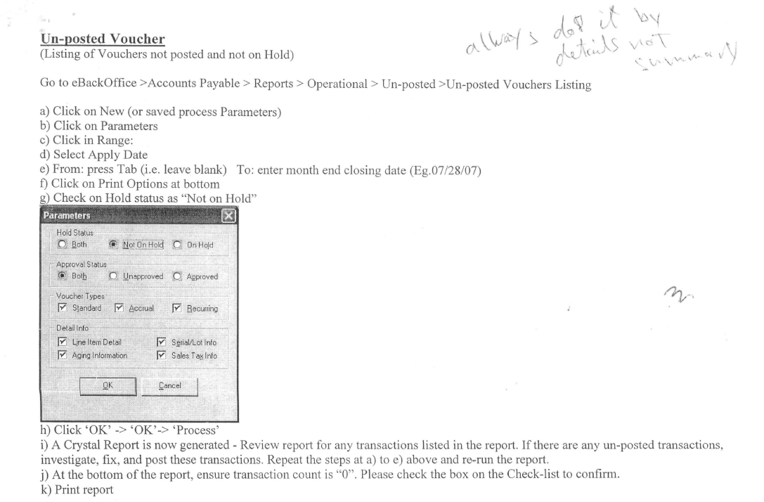

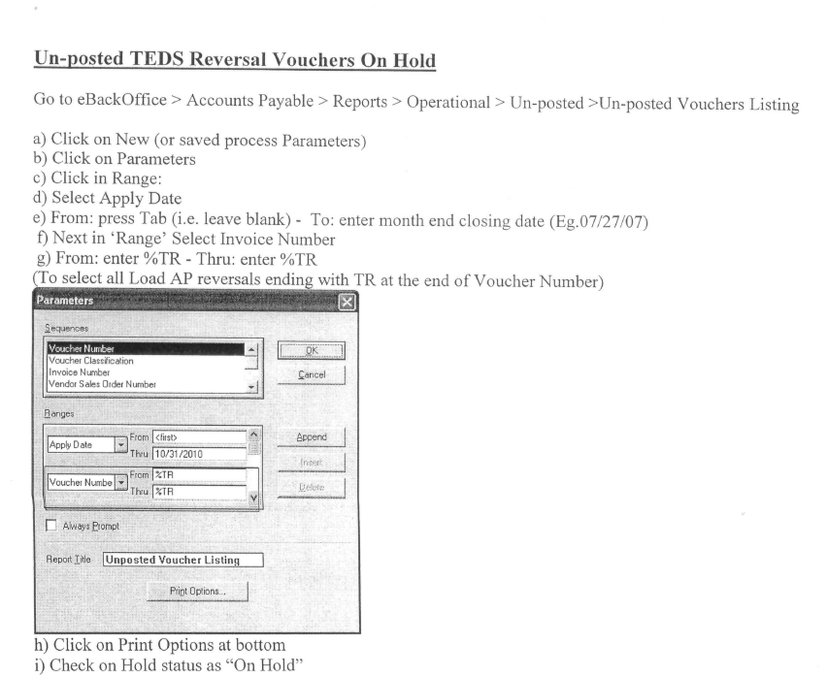

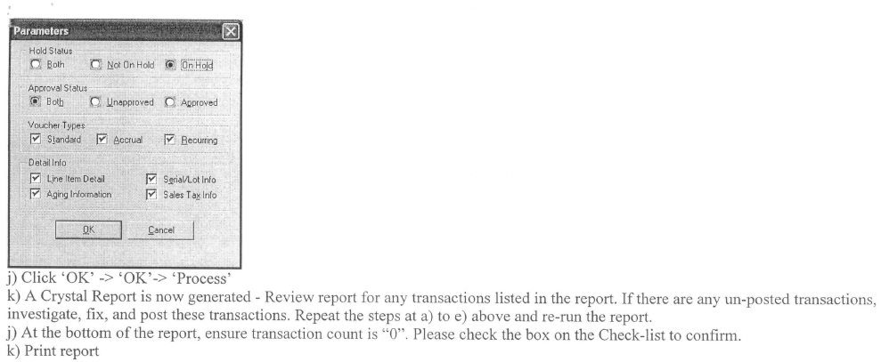

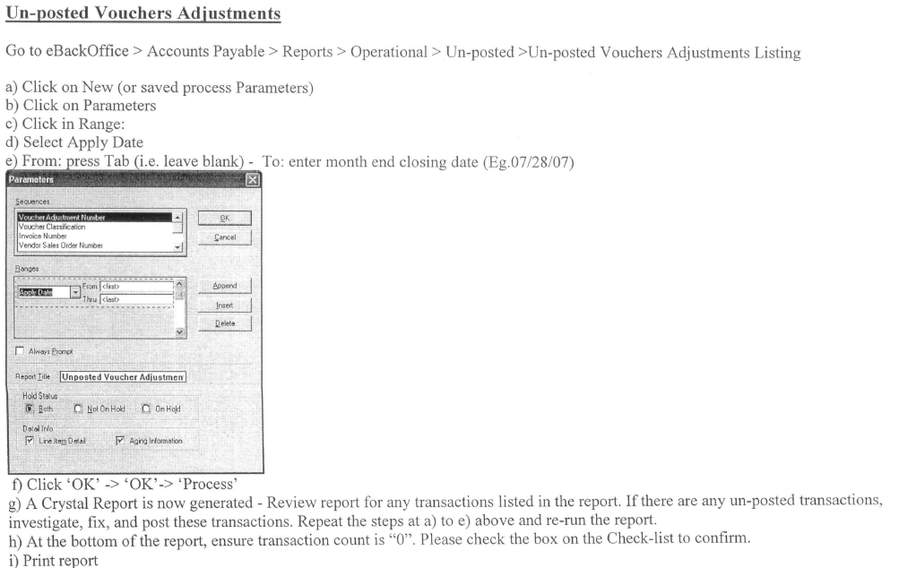

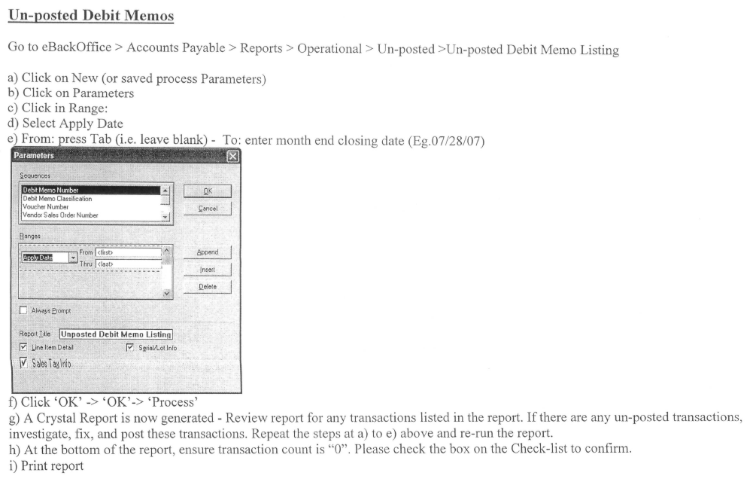

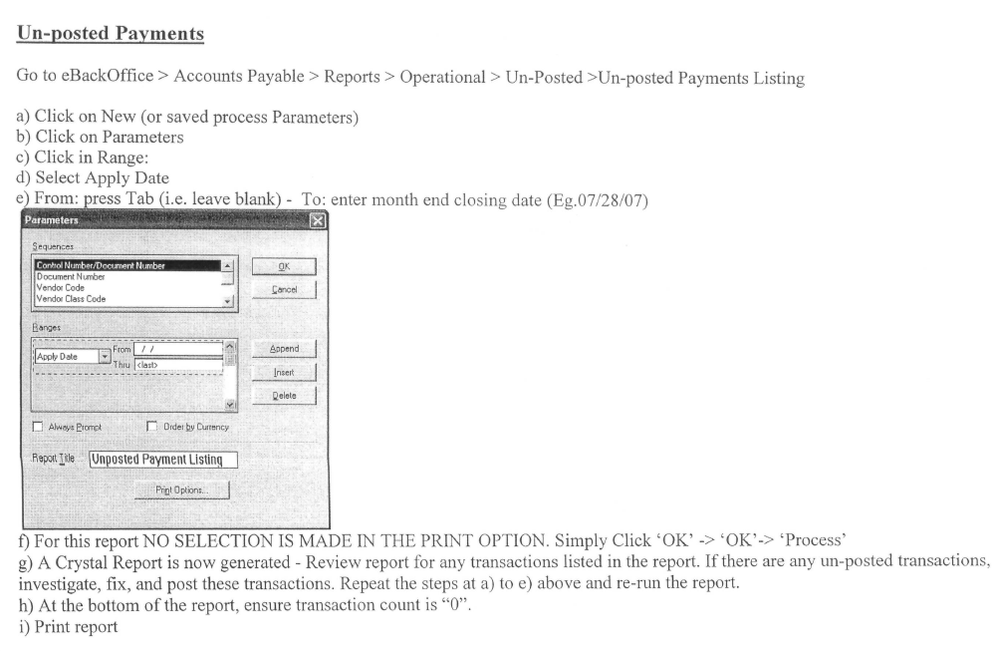

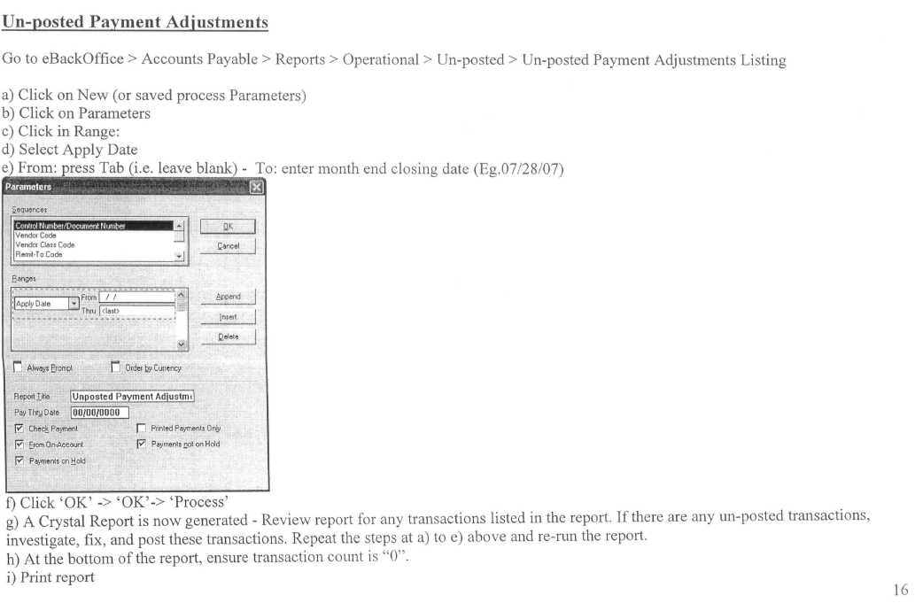

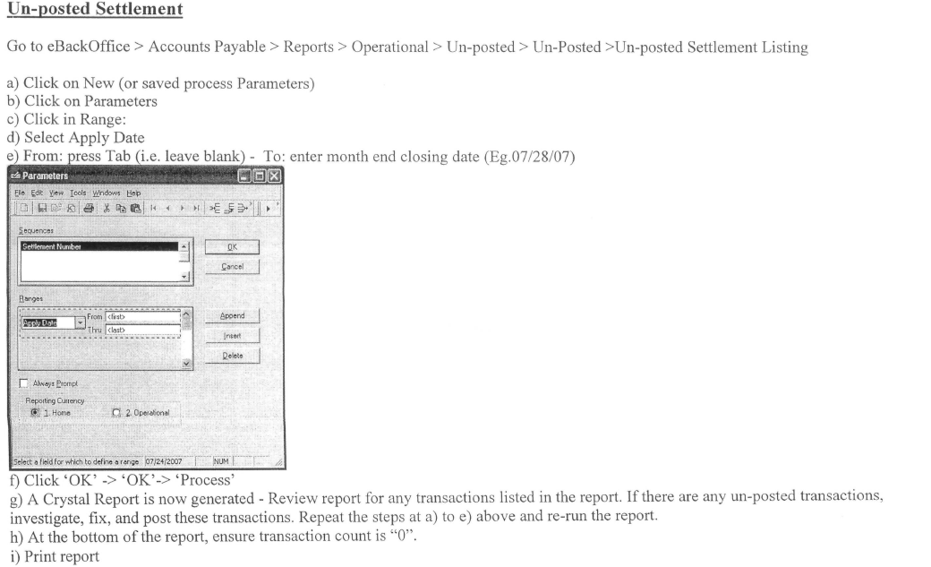

## 6.10 AMEX WEBSITE PAYING DETAILS

AMEX STMT IS GENERATED ON 10TH OF EVERY MONTH, MAKE SURE TO PAY BEFORE THE 5TH OF THE NEXT MONTH

MAKE A PAYMENT

ALWAYS PAY STATEMENT BALANCE NOT CURRENT BALANCE

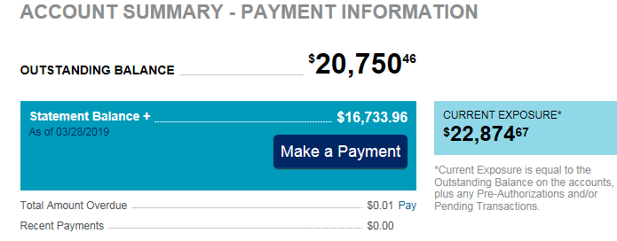

THERE ARE 3 CARDS/ACCOUNT#S CLICK ON ACCOUNT # SHOWING OUTSTANDING BALANCE

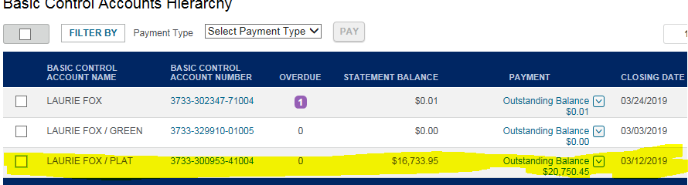

THIS STMT WAS GENERATED ON MARCH 12, MAKE SURE THIS IS PAID BEFORE APRIL 5 2019

NOW YOU WILL SEE 3 MORE PEOPLE, CLICK ON HARRY SMIT

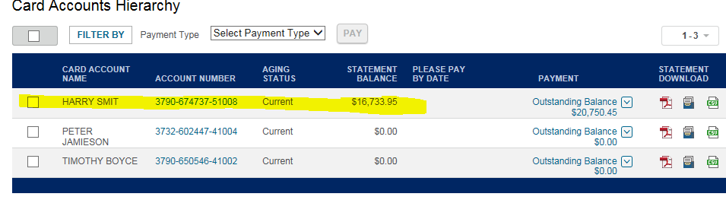

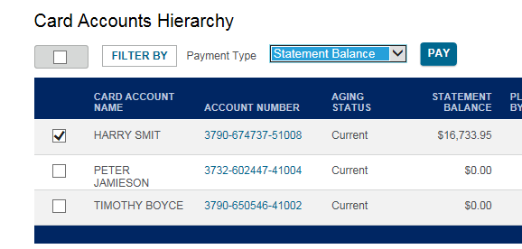

UNDER PAYMENT TYPE YOU WILL NORMALLY CHOOSE STATEMENT BALANCE

OTHER AMOUNT IF YOU ARE SHORT PAY OR THEY GIVE US A CREDIT

CLICK PAY, SELECT BANK BMO 7368 MAKE SURE AMOUNT IS MATCHING WITH YOUR STATEMENT

THEN CLICK SUBMIT. TRANSACTION DATE SHOULD BE THE DATE YOU WANT TO PAY THEM/SAME AS PYMT REG

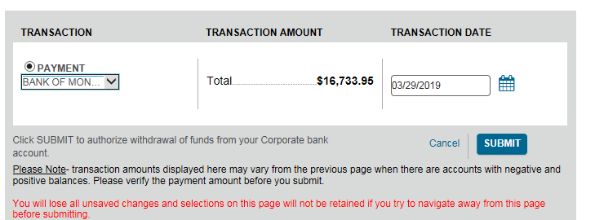

PRINTING REPORTS TO PROVE PAYMENT

GO TO SCHEDULED PAYMENTS IF YOU ARE PAYING IN ADVANCE/AT A FUTURE DATE

THERE WILL BE A TRANSACTION # THEN YOU CLICK THEN IT WILL SHOW YOU

PAYMENT HISTORY CLICK ON TRANSACTION # PRINT DOWNLOAD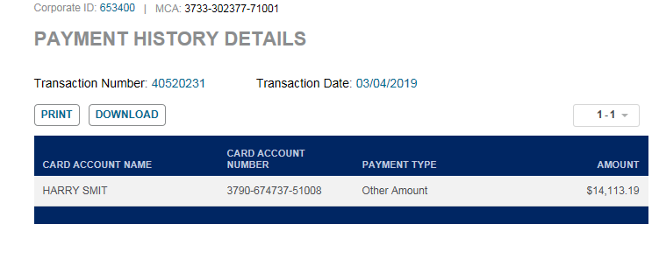

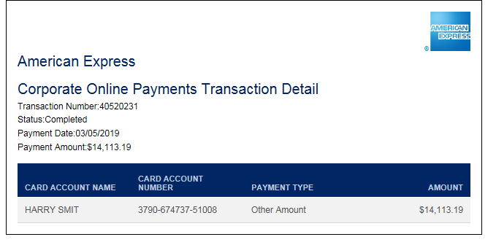

IF IT’S A SCHEDULED PAYMENT, NO AMOUNT WILL SHOW HERE

# 7.0 records

# 8.0 revision history

|  |  |  |
| --- | --- | --- |
| **Revision #** | **Revision Date** | **Description** |
|  |  |  |